Professional Responsibility:

An Open-Access Casebook

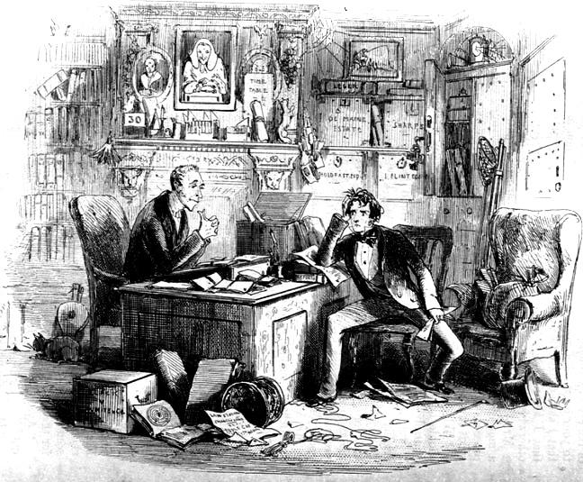

Brian L. Frye

Elizabeth Schiller

S.J. Morrison



Cover:

Hablot Knight Brown or “Phiz”

*Attorney and Client, Fortitute and Impatience* (1853)